**Homework Guideline (Topic 3)**

1. **Screenshot**

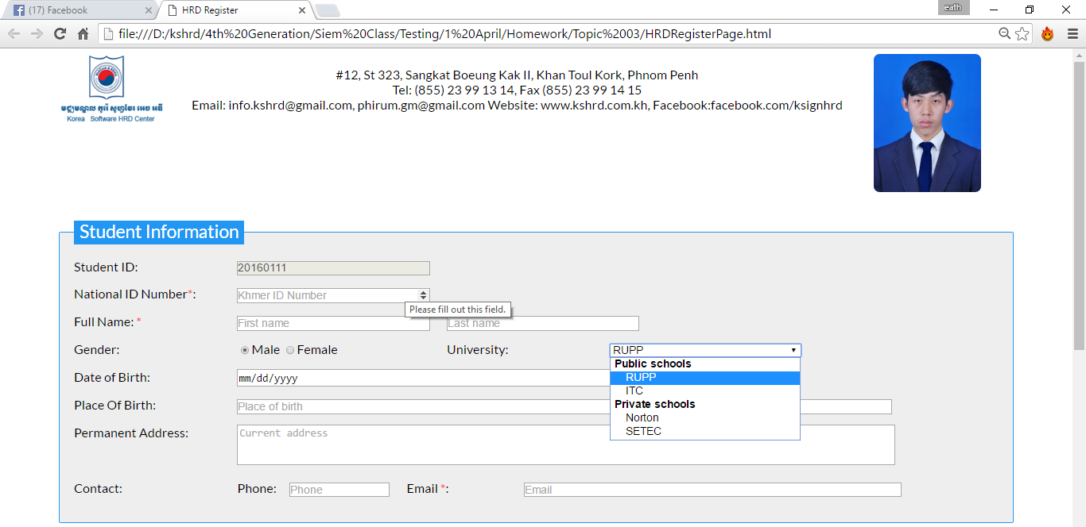

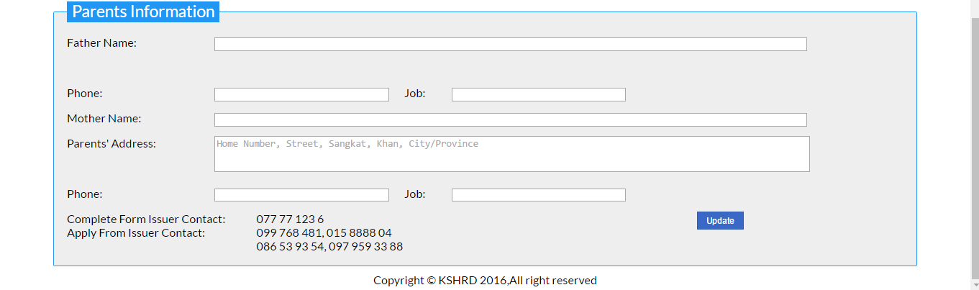

1. **Objective**

* Understanding about how to use div
* Difference between div and table
* How to use form and understand about its attribute
* Applying CSS

1. **Deadline**

* Start date: 10/April/2016
* Collecting Date: 18/April/2016 at 3:00pm

1. **Instruction**
2. Create a form as in the image using<div> instead of <table>
3. Using various type of form input and its attribute
4. Apply CSS as you want.
5. Better design, better score.
6. **Marking Criteria**

* Correctness: 80%
* Code Arrangement: 20%